**Image Created**

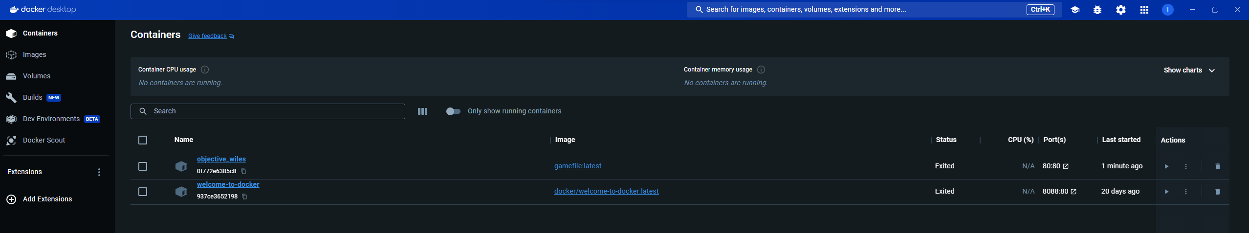

**Engine offline**

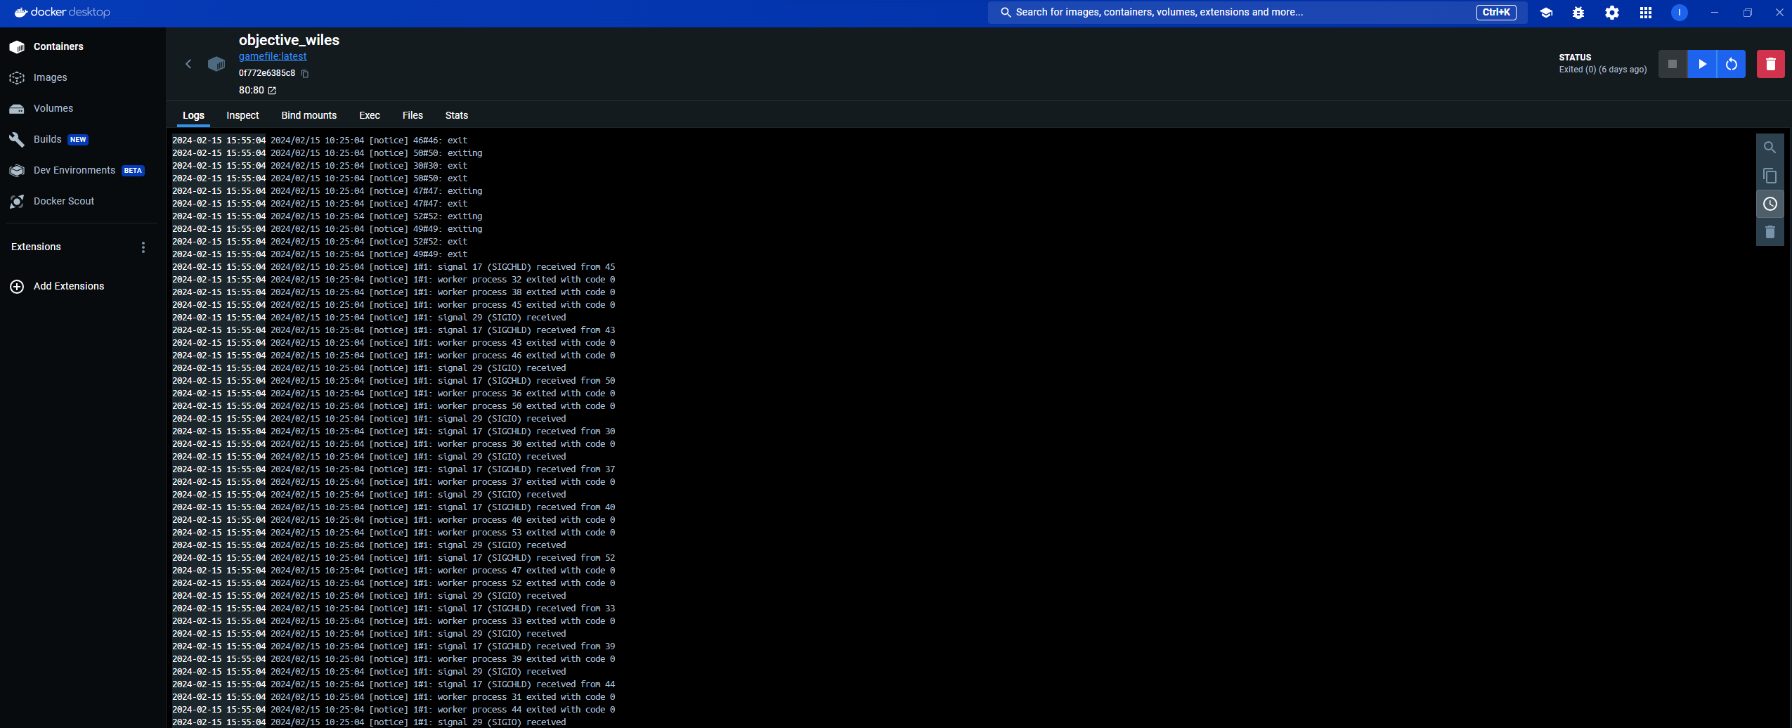

**Engine Running**

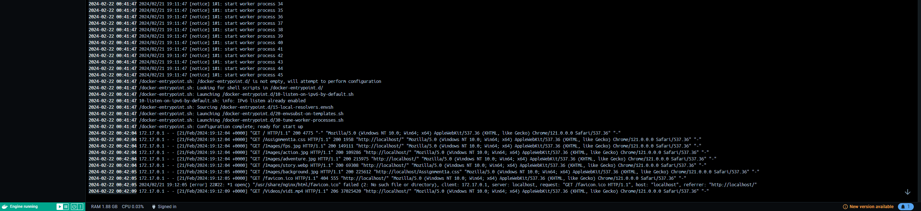

**Website Online**

